Minutes of the Argyle Free Library Board of Trustees
September 18, 2017

The meeting was called to order at 7:03PM by Remus Preda, President.
Members present: Remus Preda, Joanne McDowell, Bob Webster, Julie Gann, Jill Hamilton, Martha Johnson and Rick Dennis. Hannah Stahl, AFL Library Director, also attended.

Remus called the meeting to order at 8:05PM.

Minutes of Last Meeting:
Minutes of our July meeting were reviewed. Jill motioned to approve them with one change to the section about the technology grant, Martha seconded, and the vote was unanimous.

Treasurer’s Report:
Bob presented the Treasurer’s Report (Attachment 2). He then presented two alternate proposed budgets for 2018 (Attachment 3). We discussed the need for an increase in our revenue stream. Bob and Hannah will attend the next Argyle Town Board meeting, and try to get them to approve an increase of $1,500 from the $10,000 they have given us the past several years. We also agreed to ask for a $14,100 increase from the voters during the Argyle School District budget vote, from $44,100 last year to $58,200 this year. If we can get these increases, we will not have a budget deficit for 2018. Bob made a motion to override the school district tax cap limit, Jill seconded the motion and the vote was unanimous. Bob will submit the tax cap form. The motion is included as Attachment 4.

Library Director Report:
Hannah presented the Library Director’s report. A summary is presented below, and more details are included in Appendix 5.
- ASRL Conference: Hannah briefly discussed the seminars she attended during the conference. She will provide more details to anyone interested prior to the next board meeting (October 9 from 6:00-7:00 PM).
- Hannah’s hours: Due to her second job, Hannah requested that she work the following hours at the library:
  - Mondays 9-5
  - Tuesdays 9-5
  - Wednesdays 1-5
After some discussion, we asked Hannah if she could modify these hours so she can be at the library during some times when the commuters can visit with her at the library, maybe one evening or Saturday a month. She will check that out and let us know what she can do.
- Hannah requested that Sue and Pat work one extra hour each week so Hannah can review policies and procedures to ensure they remain aware of current policies. No decision was made, pending a review of next year’s projected income.
- Library Programs: Hannah is looking for volunteers to assist with additional library programs. Examples of possible programs include more TED talks, Armchair Traveler, and Girls Who Code. Julie volunteered to help with the Girls Who Code program, and Remus mentioned a friend who might also be interested in helping.
- Library Staff Evaluations: We discussed topics that Hannah should address as she does the performance evaluations for the library staff. Topics to be addressed include job descriptions, technical competencies, and required technical training.
- Bad Phone Connection: Hannah reported that the phone connection is frequently very noisy and difficult to hear. She will check with Spectrum about potential causes of this.
- Library Upkeep: Hannah discussed cleaning and rearranging books, painting walls, and replacing curtains. The Friends of the Library agreed to donate $600 for painting materials and new curtains.
- Overdrive Subscription Costs: Overdrive subscription costs will be increased for 2018. They will be 3% of our materials budget, with a not-to-exceed cap of $5,000.

Old Business
- Strategic Plan: Most of the ASK questionnaires have not been completed yet. Those that are completed are in the top file drawer of the file cabinet near the public computers.
- Construction Grant: A final contractor has not yet been selected. Remus will talk with the contractors to try to complete this.
- Final Sills/Foundation Repair Report: This work is completed.

New/Other Business:
- Rick resigned from the Board, effective as of the end of this meeting.
Following is the schedule for future board meetings. They will continue to be held at 7:00PM the second Monday of each month, unless otherwise noted.
  - October 9

The meeting was adjourned at 9:55 PM.

Respectfully submitted,
Julie Gann, Secretary

Action Items
Person Responsible | Task | Status / Notes
?? | 7/17/17: check with Joseph Cutshall King re a program on local history
All Board Members | 9/18/17: review Hannah’s request for additional hour/week for Pat & Sue | Pending resolution of 2018 revenue
Hannah | 9/18/17: check with Spectrum re cause of noisy phone connection
Julie | 9/18/17: Update written requirements for the bathroom renovation. | 10/5/17: Julie send draft of requirements to Remus, Bob & Hannah
Remus | 9/18/17: talk with the contractors re final bid based on the updated written requirements.
Phyllis | 7/17/17: continue coordination with Elna about a program to discuss her books
Hannah | 7/17/17: draft job descriptions & pay scales for each
Hannah | 7/17/17: check with Sarah to see if volunteers can check books in and out
Julie | 7/17/17: check with Carol Kuhr to see if the planned 7/25 date for the SP Committee works for her | 7/18/17: complete
Julie | 7/17/17: move prom gowns from her home to bank
?? | 7/17/17: need to consider repair/replacement of some book shelves that are bowing under the weight of the books
Julie | 6/16/17: Bob gave her the grant application from the Home for Aged Women to complete, which could provide the remaining funding for the bathroom renovation | 7/6/17: grant was submitted; should hear results before September
Bob | 6/12/17: give direct deposit forms to Hannah | 7/17/17: open
Hannah | 6/12/17: give direct deposit forms to employees with guidance on filling them out and returning to Bob if they want direct deposit of their paychecks | 7/17/17: open
Hannah | 6/12/17: prepare a Program Attendance & Cancellation Policy after the Strategic Plan is complete | 7/17/17: see minutes for approach, policy needs to be documented
Rick | 6/12/17: get final bids from contractors for the bathroom renovation | 7/17/17: in progress
Hannah | 6/12/17: contact the Post Star, et al to see about a new article that the prom gowns are available for special occasions | 7/17/17: open
Hannah | 6/12/17: new Book Donation policy | 7/17/17: revise in accordance with discussion
Hannah | 6/12/17: do a performance evaluation for the library staff | 7/17/17: waiting on approved job descriptions & pay scales
Hannah | 5/8/17: put a signature page on each magazine for patrons to sign when they read, so Hannah can track which subscriptions are being used | 7/17/17: started
Remus  Phyllis | 5/8/17: contact Sarah Dallas and Kim McLean about letters of recommendation for the ‘Best Small Library’ grant application | 7/17/17: 1st draft of Schubert grant application is in progress, will put on podkeeper; not doing the ‘Best Small Library’ application this year  6/12/17: working, dependent on decision about whether or not to submit this year
Jill | 5/8/17: check with local museums/attractions about a season pass we can offer our patrons | 7/17/17: completed; will purchase GF Children’s museum pass  6/12/17: talked with MiSci Museum, $200 for 2 family passes, each gets 2 adults and all kids in free; will look at other options
Jill | 4/17/17: work with Bob to understand the Treasurer’s duties and software; let the Board know if she is willing and able to take over permanently when Bob leaves in October | 7/17/17: Quicken & wi-fi stick have been purchased; goal is for Jill to take over treasurer duties after August meeting  6/12/17: in progress, working on getting computer set up, may need wi-fi stick and copy of Quicken
Hannah, Julie | 4/17/17: convert the digitized yearbooks to Adobe pdf format | 7/17/17: In progress. Hannah will check with SALS about getting Adobe Professional to convert the files.
Hannah | 4/17/17: develop DB with photos of prom dresses, advertise availability for special occasions. | 6/12/17: in progress
Bob | 2/13/17: approved Pete Narkewick to do the foundation/sill repair work using that grant money. Bob to keep board apprised of status. | 7/17/17: start date in about 4 weeks (mid-August)  6/12/17: no start date yet
All Board members & Hannah | 12/12/16: prepare a list of potential stakeholders and facilitators for discussion at our January meeting | 7/17/17: 1st meeting of Strategic Plan committee scheduled for July 25  1/16/17: postponed to February meeting
Bob, Martha, Hannah | 12/12/16: Bob will talk with Ryan, Martha will talk with her son, and Hannah will check with some homeschoolers about being youth representatives for our Long Range Planning meeting(s). | 7/17/17: topic for SP Committee  1/16/17: still being worked
All | 11/14/16: Review Strategic Planning documents in ‘Files’ section of PodKeeper:  - New Planning for Results  - Simply Strategic  - Aspen Institute  - Read pp. 57-59 of the Handbook for Library Trustees to prepare for our discussion of the Long Range Plan. | 7/17/17: topic for SP Committee  1/16/17: carried over to February meeting  12/12/16: carried over to January 2017
Hannah | 10/17/16: draft a Collection Development Plan | 6/12/17: wait until after the Strategic Plan is complete  5/8/17: wait until after the budget vote, as will impact the acceptance of donated books  1/12/17: needs to make a few changes; plan on draft ready for review in May 2017  11/30/16: draft posted to PodKeeper
All Board members | 12/12/16: review the success of the café space and determine whether to continue and how to fund | Due December 2017

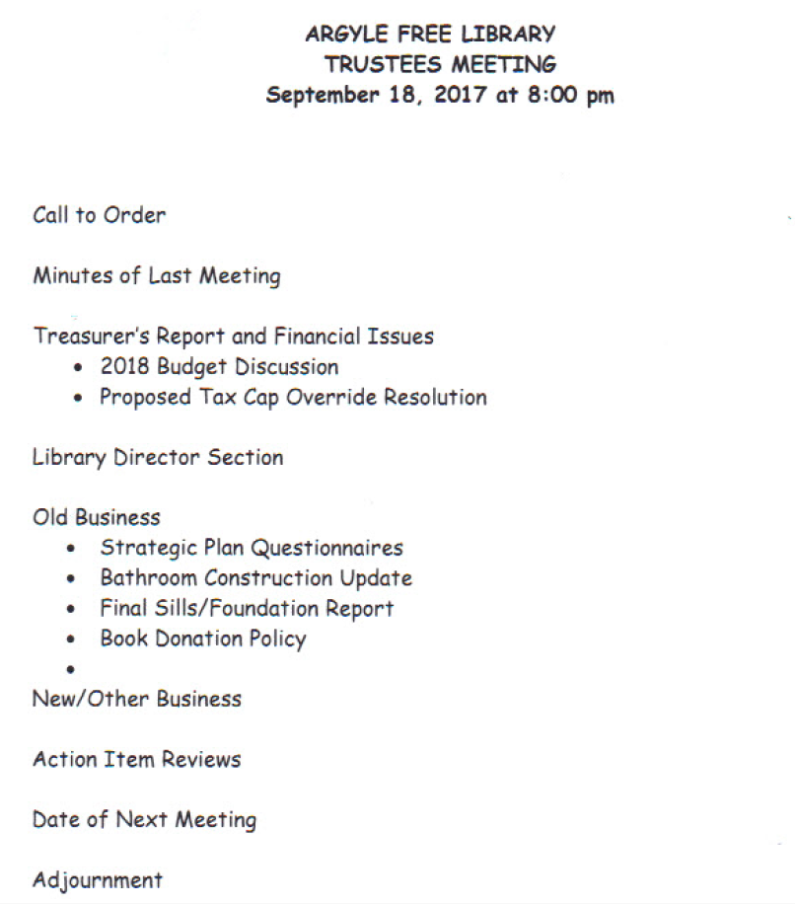

Treasurer’s Report
September 2017

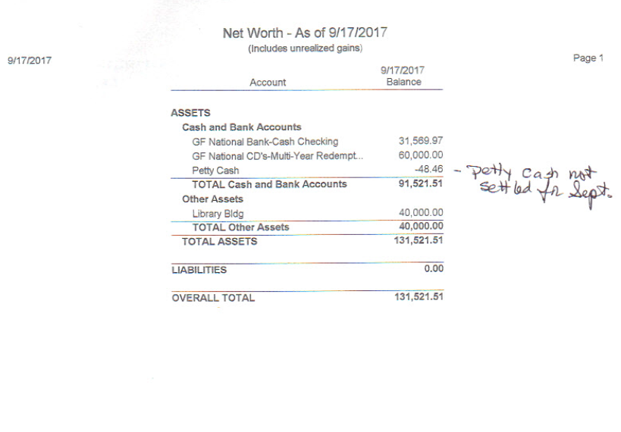

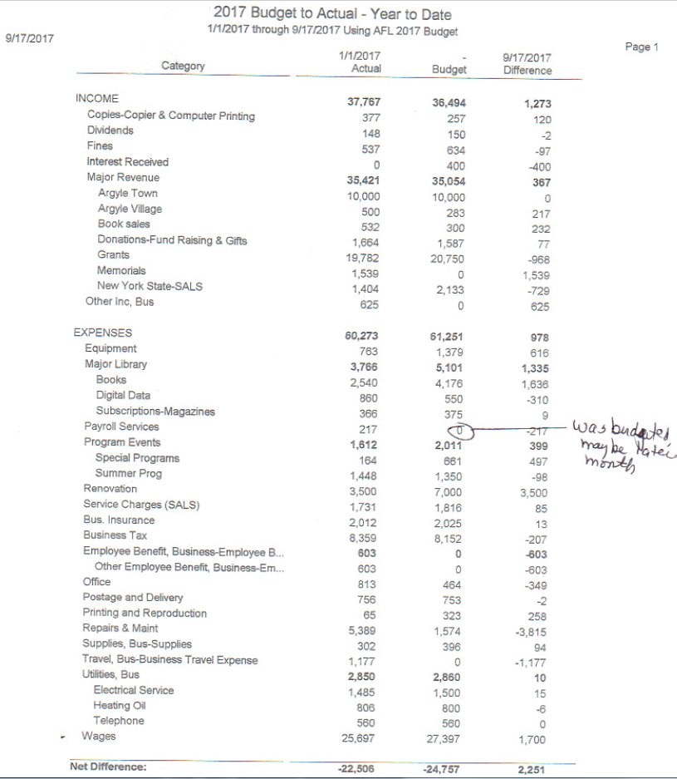

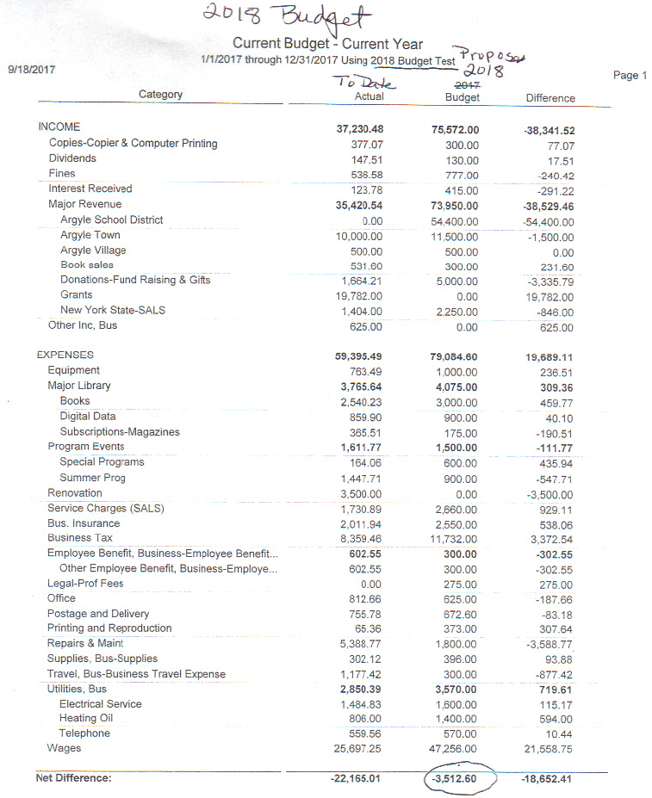
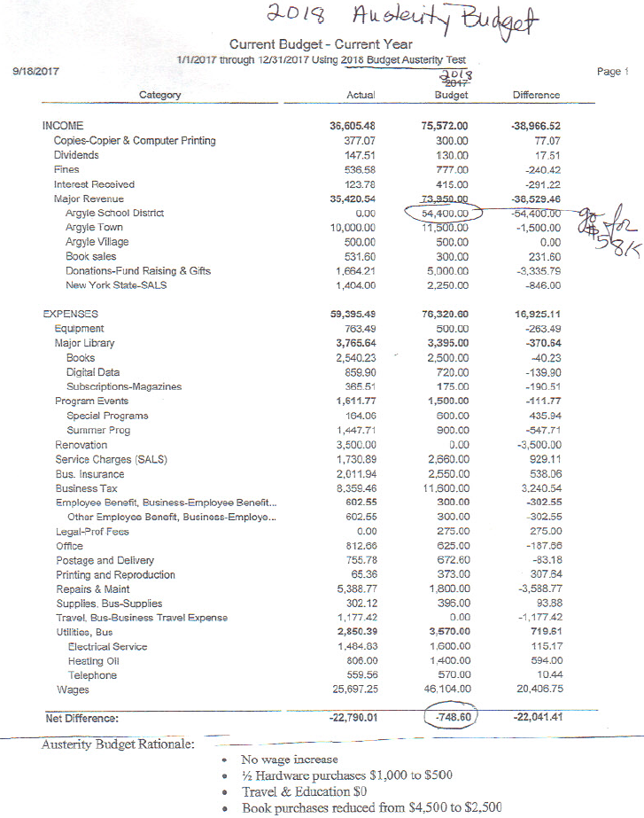

Argyle Free Library
Tax Cap Overide Resolution for 2018

Whereas, the adoption of the 2018 budget for the Argyle Free Library may require a tax levy increase that exceeds the tax cap imposed by the state law as outlined in General Municipal Law Section 3-c adopted in 2011; and

Whereas, General Municipal Law Section 3-c expressly permits the library board to override the tax levy limit by a resolution approved by a vote of sixty percent of qualified board members; now therefore be it

Resolved, that the Board of Trustees of the Argyle Free Library voted and approved to exceed the tax levy limit for 2018 by at least the sixty percent of the board of trustees as required by state law on September 18, 2017.

